* Jet2Holidays, a lot of the tabs along the top are out of scope
* How they’re build, why they are build the way they are
* Autocomplete seems to be relevant.

Just get it listed, can be reworked over time

Maybe names can be quite descriptive. Address vs airport_address

Consistency in naming conventions is important

Picking lots of “columns” is better than picking too little, as you can discard stuff not necessary as time progresses

* Airports entity likely (airport)
  + airport_name
  + airport_code (3 letter code)
  + gps_lat
  + gps_long
  + address (naïve) more there obviously – could be entity
    - postcode, address line 1 etc
  + region
  + city
* Route
  + Departure_airport
  + Arrival_airport
* Resorts
* Graphical user interface, application

  Description automatically generated
  + Resort_name,
  + Description,
  + Region
  + Country
* Hotel
  + Hotel_name
  + Location – naïve possibly
  + Star_rating – enforce range (1-5 eg)? – another entity maybe?
  + Price_per_night
  + Coach_transfer
* Board
  + Board_name
  + Board_description
* Room
  + Room_name
  + Sleeps_min
  + Sleeps_max
* Facilities
  + Facility_name
  + Facility_description

Note: package holidays add some complexity over something like Airbnb. How can we scope down the flying aspect

Week 1 Thursday lecture 02:19:00 in recording had some info about scoping of various sub systems

Anything where there is an upsell – just ignore.

Aircraft seats, meals etc, forget about it

Hotels, resorts, flights yes, lots of other upselling and extras, don’t worry.

Covid nah, travel insurance nah… kids clubs, terraces sure.

* Duration
  + ????
* Customer
  + Customer_firstname
  + Customer_surname
* Passenger
  + Title
  + First_name
  + Surname
  + Dob

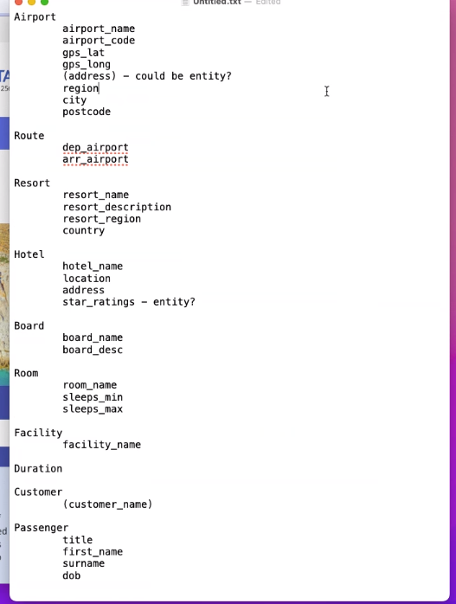

DROPDOWNS, SEARCHES, FORMS, SCREAMS DATABASE. It has to be backed by data (entity attributes)

Design decisions are variable, but how you justify it or explain it is where the marks come from

**27/09/2022**

Focus is on package holdiers “glorified hotel database”

If a room is available assume corresponding flight

Things like guestTypes tables with only a few rows is fine

Play with stuff, eg prices, check with different numbers of adults and kids etc, see how it affects the price.

would you take into account different prices from different airports? Or treat all airports the same? Is it the date that effects it, is it the distance, is this stored somewhere as prices for each permutation, or is it calculated?

should we be factoring in different prices at different times of the year? and include flights with two legs or just assume direct flights? Reasonable assumptions about to leave out. Don’t touch multi leg flights, save your sanity. Different time of year is worth looking into.

so in a pricing table should you be doing like a base price for the package holiday then price adjustments calculated based on % at different ties of years and different airports? Storing multipliers and stuff? Acceptable. Demonstrating dynamic pricing based on dates.

Table numbers have often ended up in the range of 20-30. This is not a hard rule, and some of these tables are small, some are large etc

2 questions - from memory on Jet2 you are able to save multiple holidays for later without buying - should we facilitate this? Yes and no, its viable information, but do you have time to speak about it in 10 minute video?

Also you can pay a deposit & settle balance later - should we allow for this? Sure, it may not even be that difficult to implement Booksing contain cost, and payments are made in payments table. Monthly payment algorithms craic not in scope.

Do we need to worry about concurrent bookings with limited availability (like ticketmaster reserving a ticket and giving you 15 minutes to check out). Ticketmaster has presumptive booking. A selected holiday on website may store a in progress booking with a status saying like “unconfirmed”. Payment just switches status from unconfirmed to confirmed. There is a concurrency management system in place, but the limitations of it are largely unknown from the outside.

Room Types: are the particular to hotels, or are they hard categories across all hotels?

Forget about luggage and sports equipment.